ATMOSPHERIC ATTENUATON OF SIGNAL WAVES

* Atmospheric attenuation, which is primarily atomic and molecular absorption of the beam along the path.
* Attenuation decreases the intensity of electromagnetic radiation due to absorption or scattering of photons.
* It is due primarily to water vapor absorption lines, is very significant in many spectral regions in the millimeter-wave and terahertz bands.

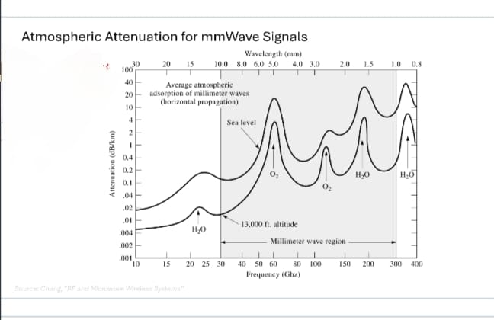

ELECTRON-DENSITY PROFILE OF IONOSPHERE

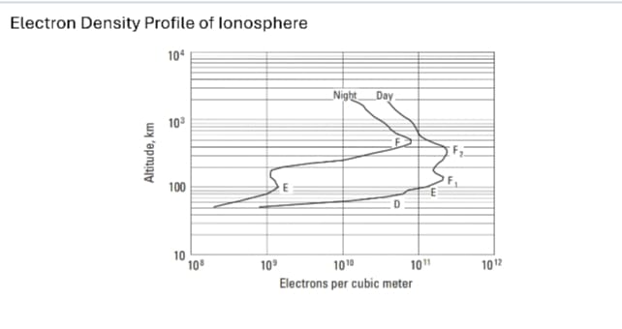

CARRIER FREQUENCY

* It is the frequency of a carrier wave, measured in cycles per second, or Hertz, that is modulated to transmit signals.
* The frequency carrier waves travel through space or medium with the speed of light and they are not obstructed by earth's atmosphere.

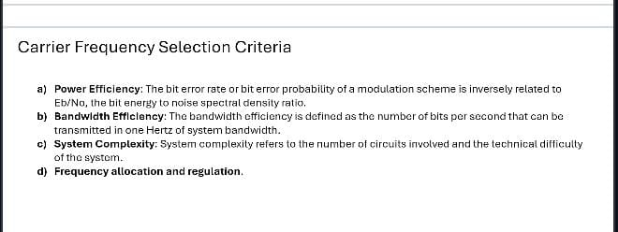

BASIC-ORBIT FUNDAMENTALS

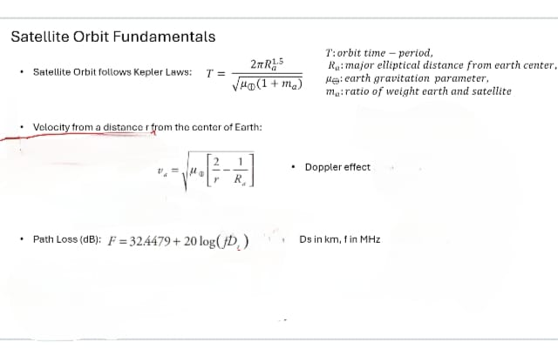

TYPES OF ORBITS

* LEO-

1. Stands for Low Earth Orbit.
2. Used for communication and remote sensing satellites.

* MEO-

1. Stands for Medium Earth Orbit.
2. Used for Navigation Systems ,using GPS.

* GEO-

1. Stands for Geo Stationary Orbit.
2. Used for telecommunication and Earth’s Orbit.

* EEO-

1. Stands for Elliptical Earth Orbit.
2. Used for satellite radio, and communication.

